**Heartbleed Vulnerability Demonstration:**

Apache and Postfix Exploitation

# **Author**

Shay Hahiashvili

# **Details**

**Server:** Ubuntu Linux running OpenSSL 1.0.1c with IP 192.168.1.132

**Client:** Windows running custom Java Heartbleed exploit with IP 192.168.1.99

**Services:** Apache, MySQL, phpMyAdmin, Postfix, Dovecot

**OpenSSL Version:** 1.0.1c

**Tools:** Java Heartbleed Exploit, Bash Scripts

# **Overview**

This document demonstrates the exploitation of the Heartbleed vulnerability (CVE-2014-0160) on Apache (port **443**) and Postfix (port **465**) services running on vulnerable Ubuntu Linux server running OpenSSL 1.0.1c with IP **192.168.1.132**.

The client with IP **192.168.1.99** extracted sensitive data including passwords and secrets using my custom Java based Heartbleed exploit from vulnerable Ubuntu Linux server. For ensuring sensitive data is kept in memory of **Apache** and **Postfix** during the attack, custom Bash scripts ran on Linux server for leaking sensitive data.

# **Machines Description**

* 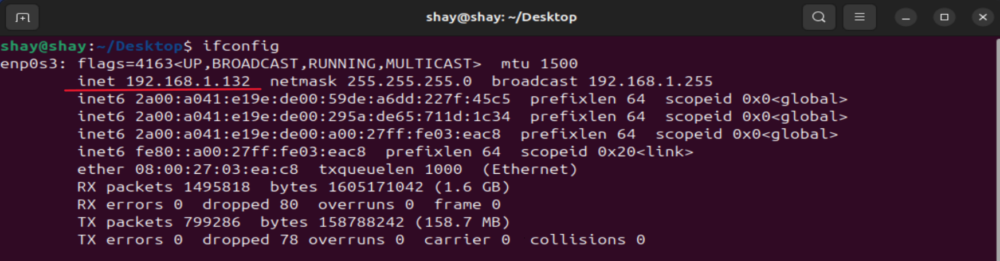**Ubuntu Linux server running OpenSSL 1.0.1c with IP 192.168.1.132**
* 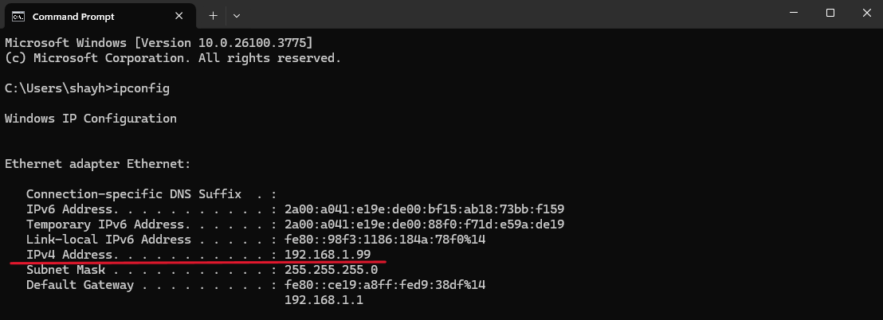**Windows running Java Heartbleed exploit with IP 192.168.1.99**

# **OpenSSL Verification**

* **Ubuntu Linux server is using OpenSSL 1.0.1c**

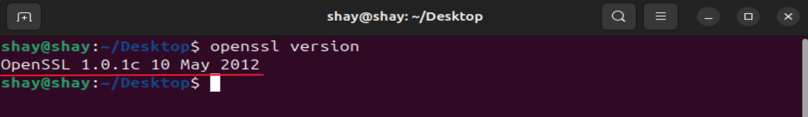

* 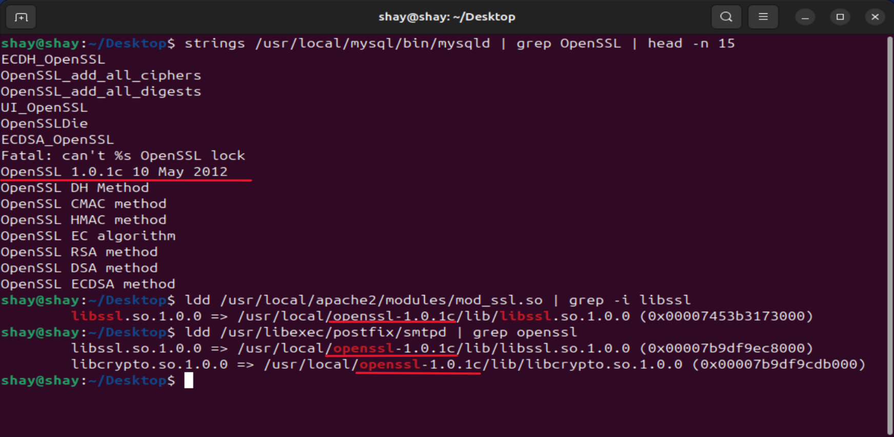**Apache, MySQL and Postfix are using OpenSSL 1.0.1c**
* 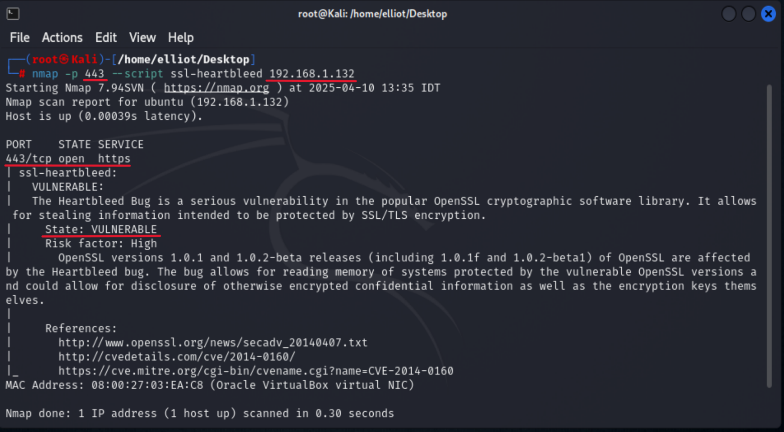**Verifying Apache is vulnerable using NMAP Heartbleed test   
  (on Kali Linux machine)**
* 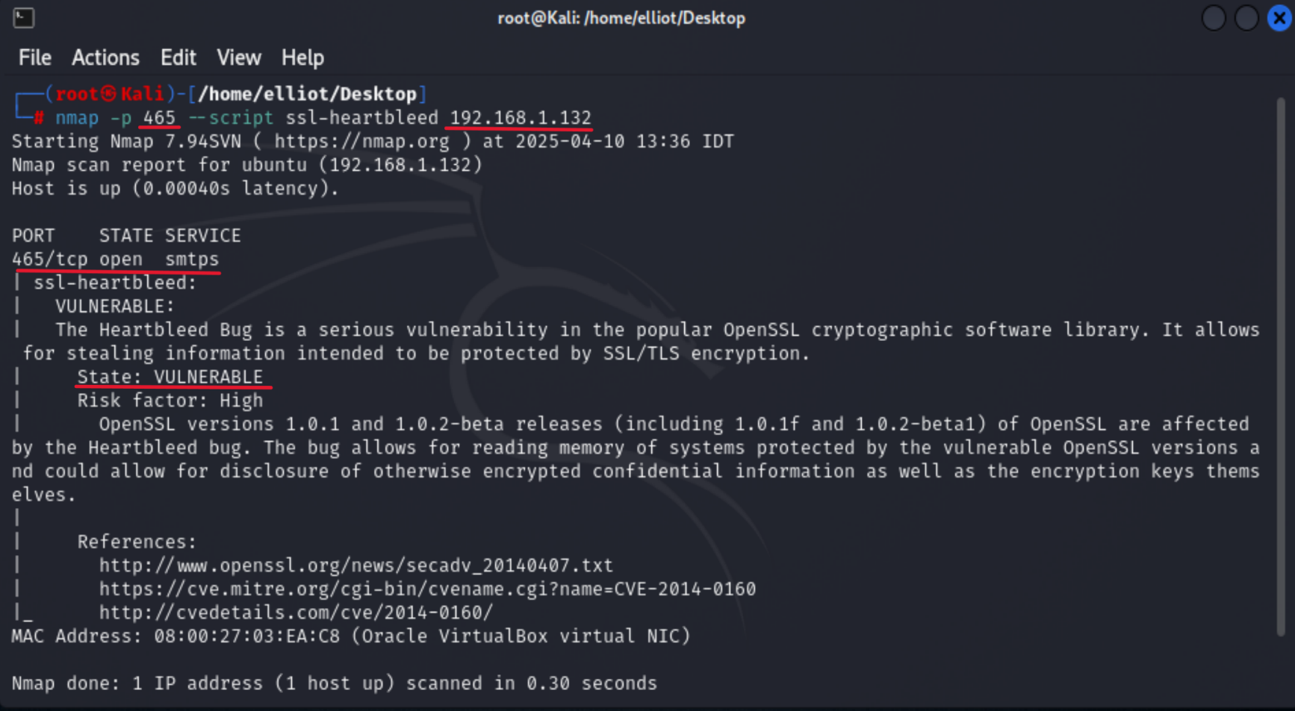**Verifying Postfix is vulnerable using NMAP Heartbleed test   
  (on Kali Linux machine)**

# **Service Verification**

* **Apache service is running on port 443 (HTTPS)**

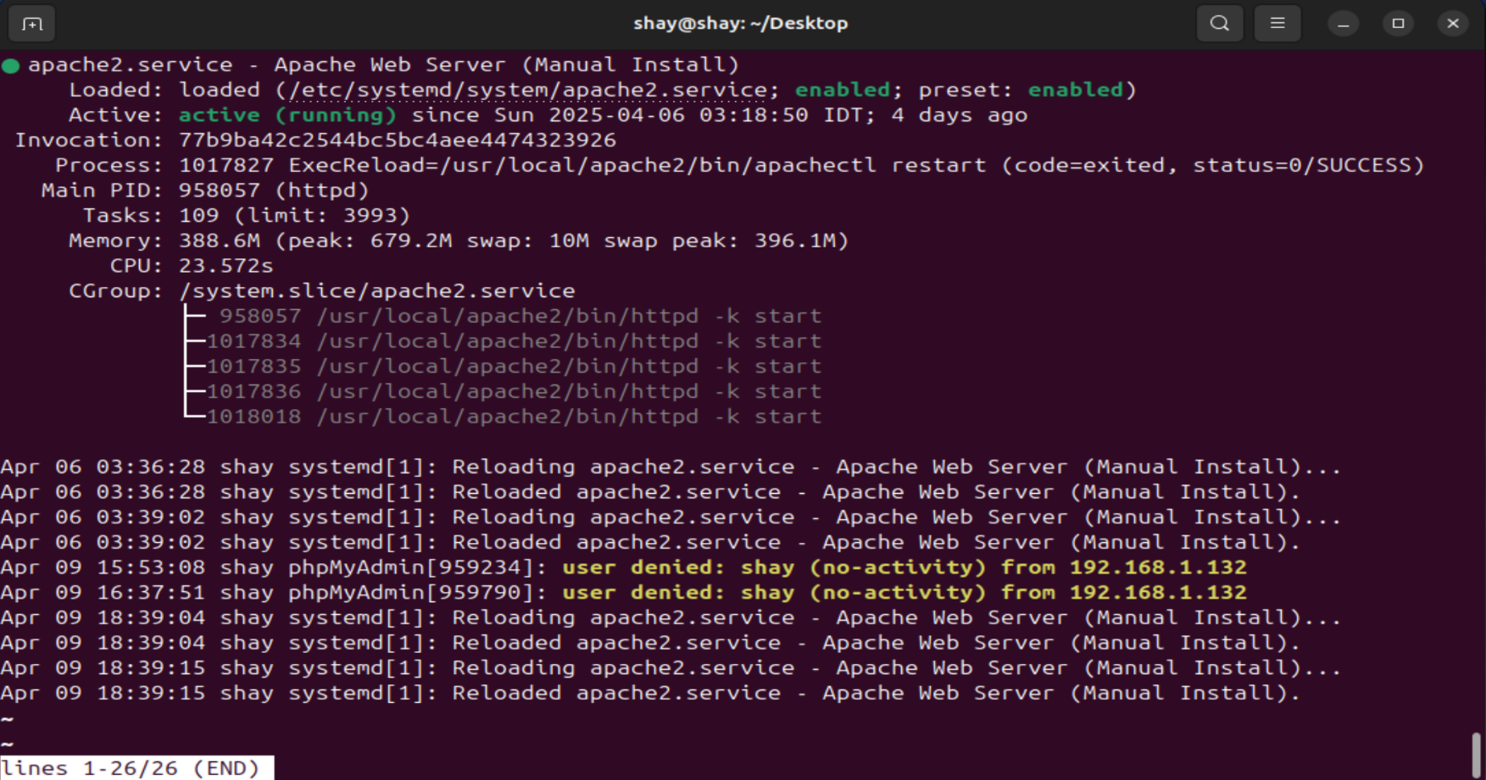

* 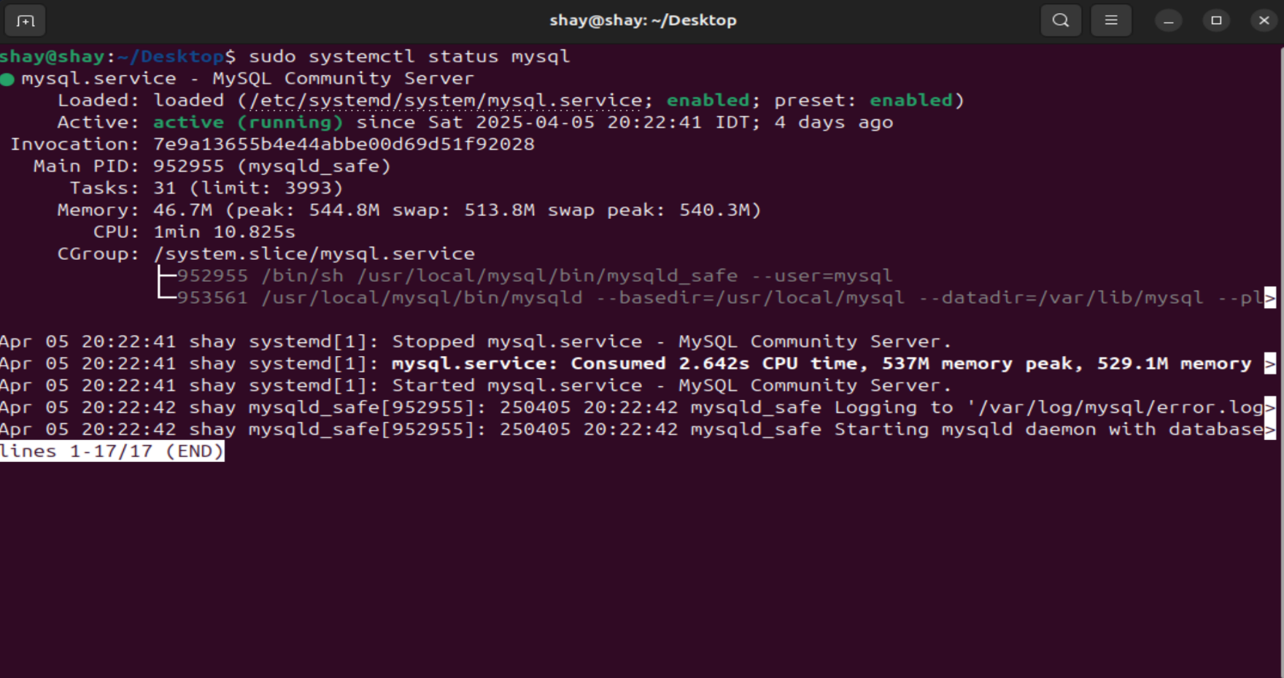**MySQL service is running with phpMyAdmin**
* 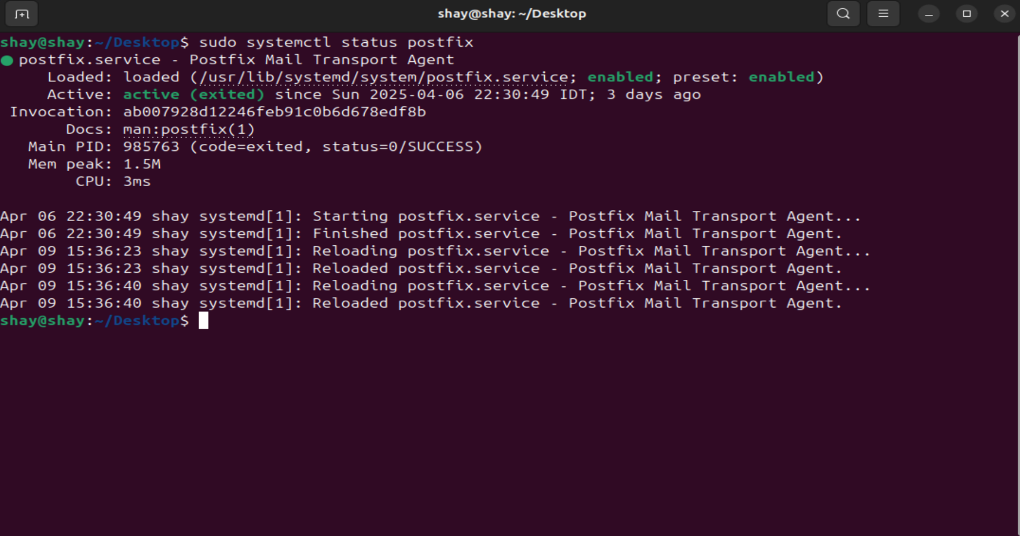**Postfix service is running on port 465 (SMTPS)**
* 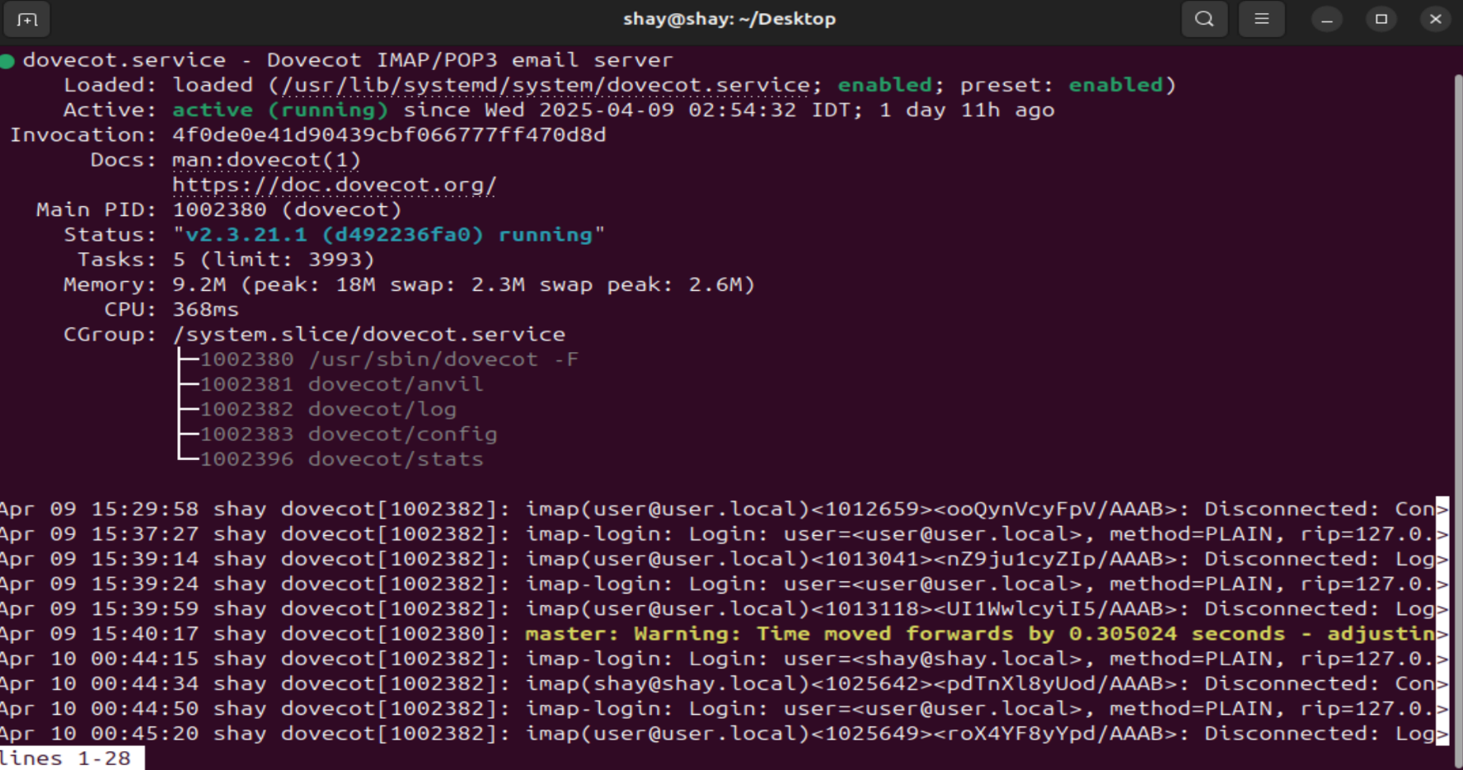**Dovecot service is running on port 993 (IMAP)**

# **Mail Users**

There are two main MySQL users, shay for general database queries and mailuser for sending mails with Postfix for local mail users, both MySQL users have their passwords stored as SHA-256 hashes.

There are two local mail users, shay@shay.local and user@user.local. In our demonstration, we send emails from shay@shay.local to user@user.local using Postfix with SMTPS on port 465. Both users are also registered in the MySQL **mailserver** database, with their passwords stored as SHA-512 hashes.

* 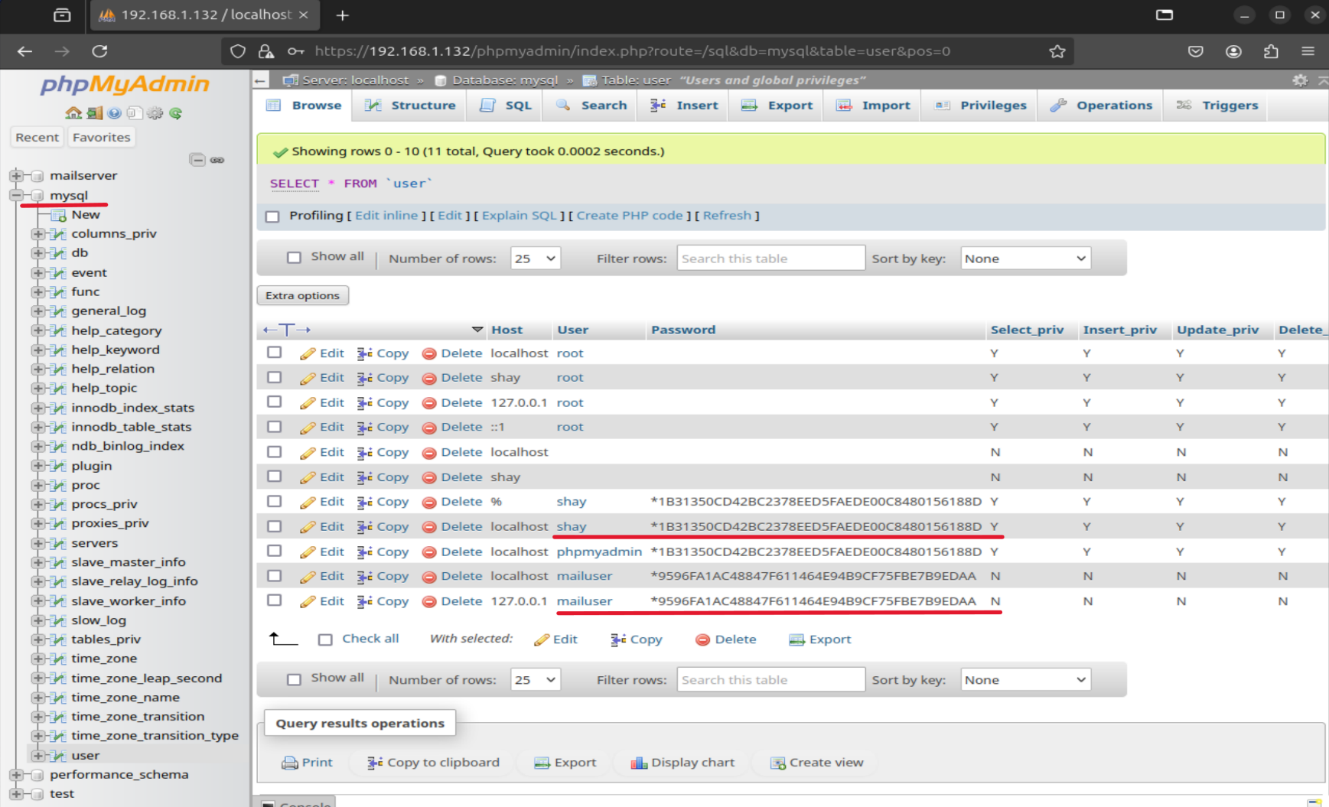 **Showing the user table in mysql database with phpMyAdmin**
* 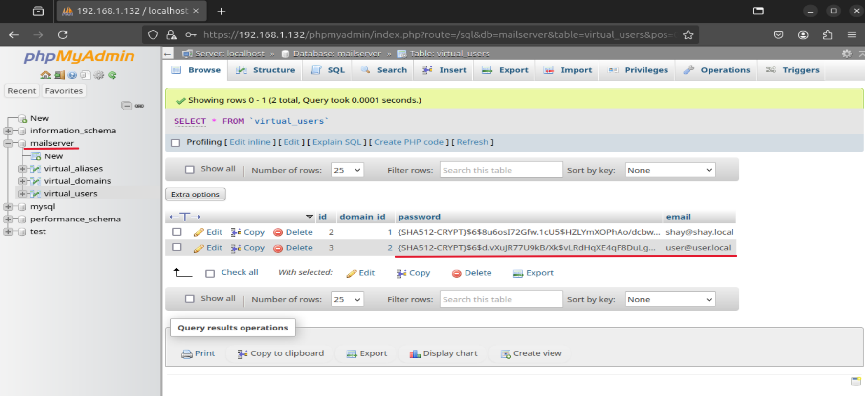**Showing the virtual users table in mailserver database with phpMyAdmin**
* 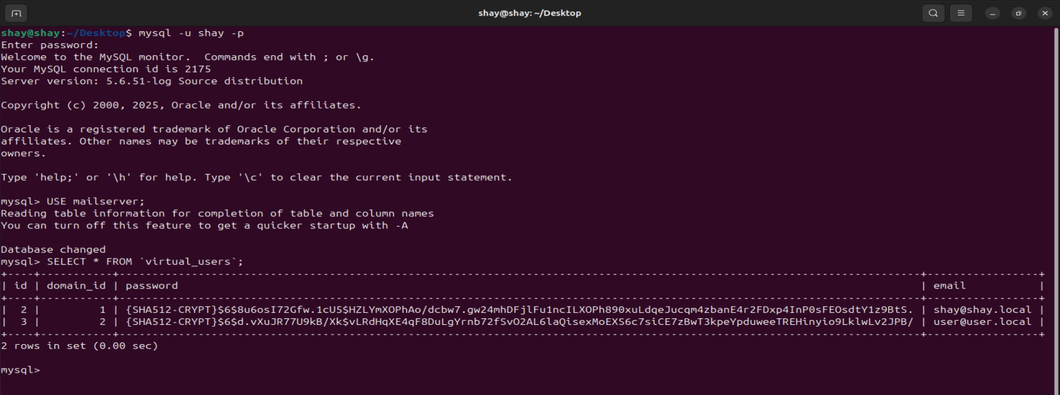**Showing local mail users in mailserver database with their hashes**
* 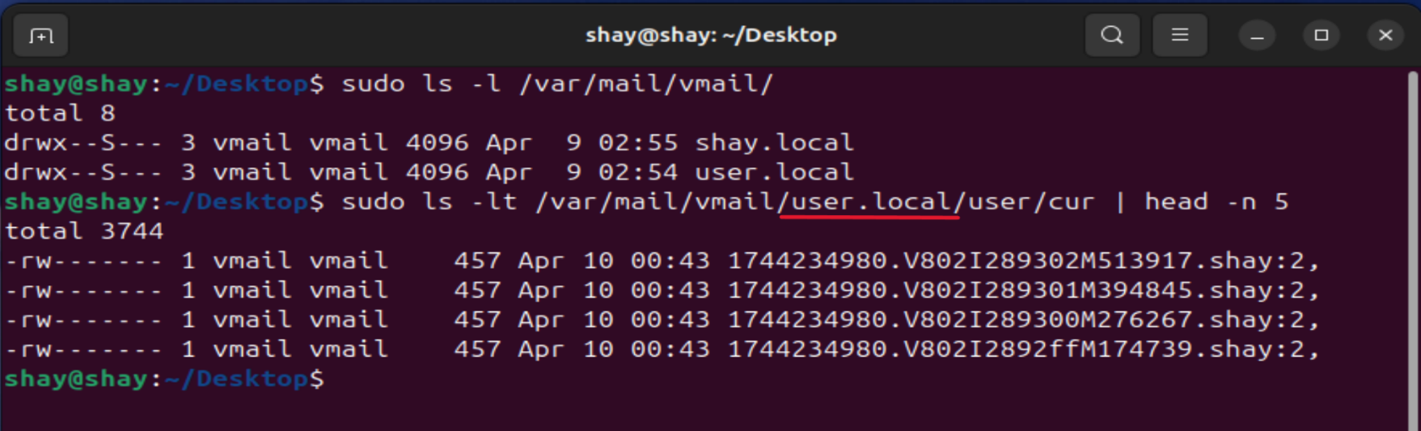**Showing user’s mailbox with emails he received from shay**

# **Postfix and Dovecot Verification**

* 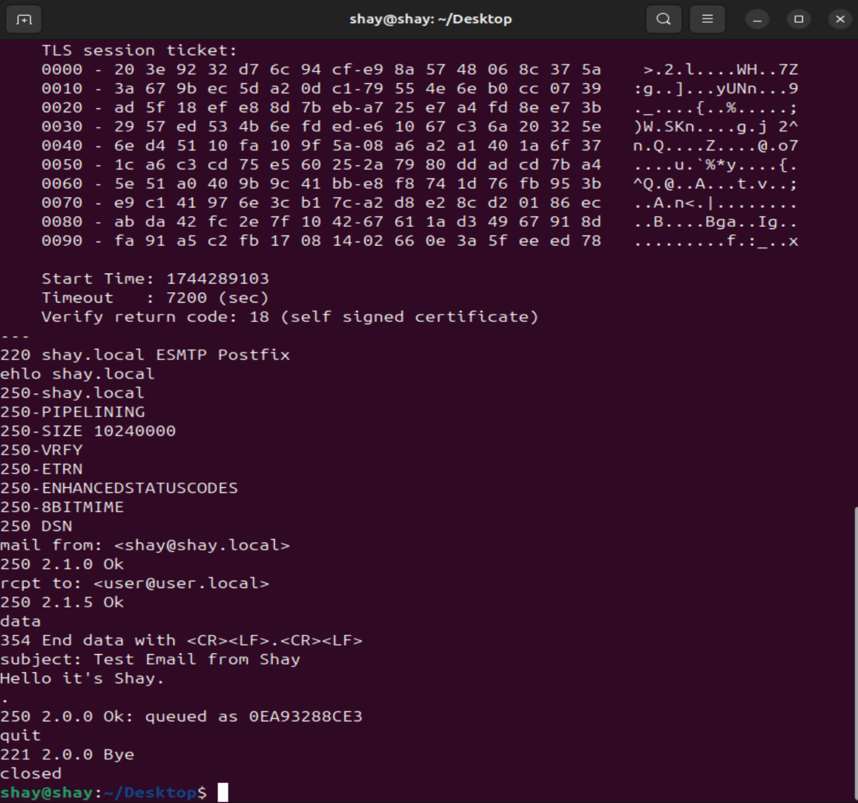**Sending email from shay to user via Postfix with SMTPS on port 465**
* 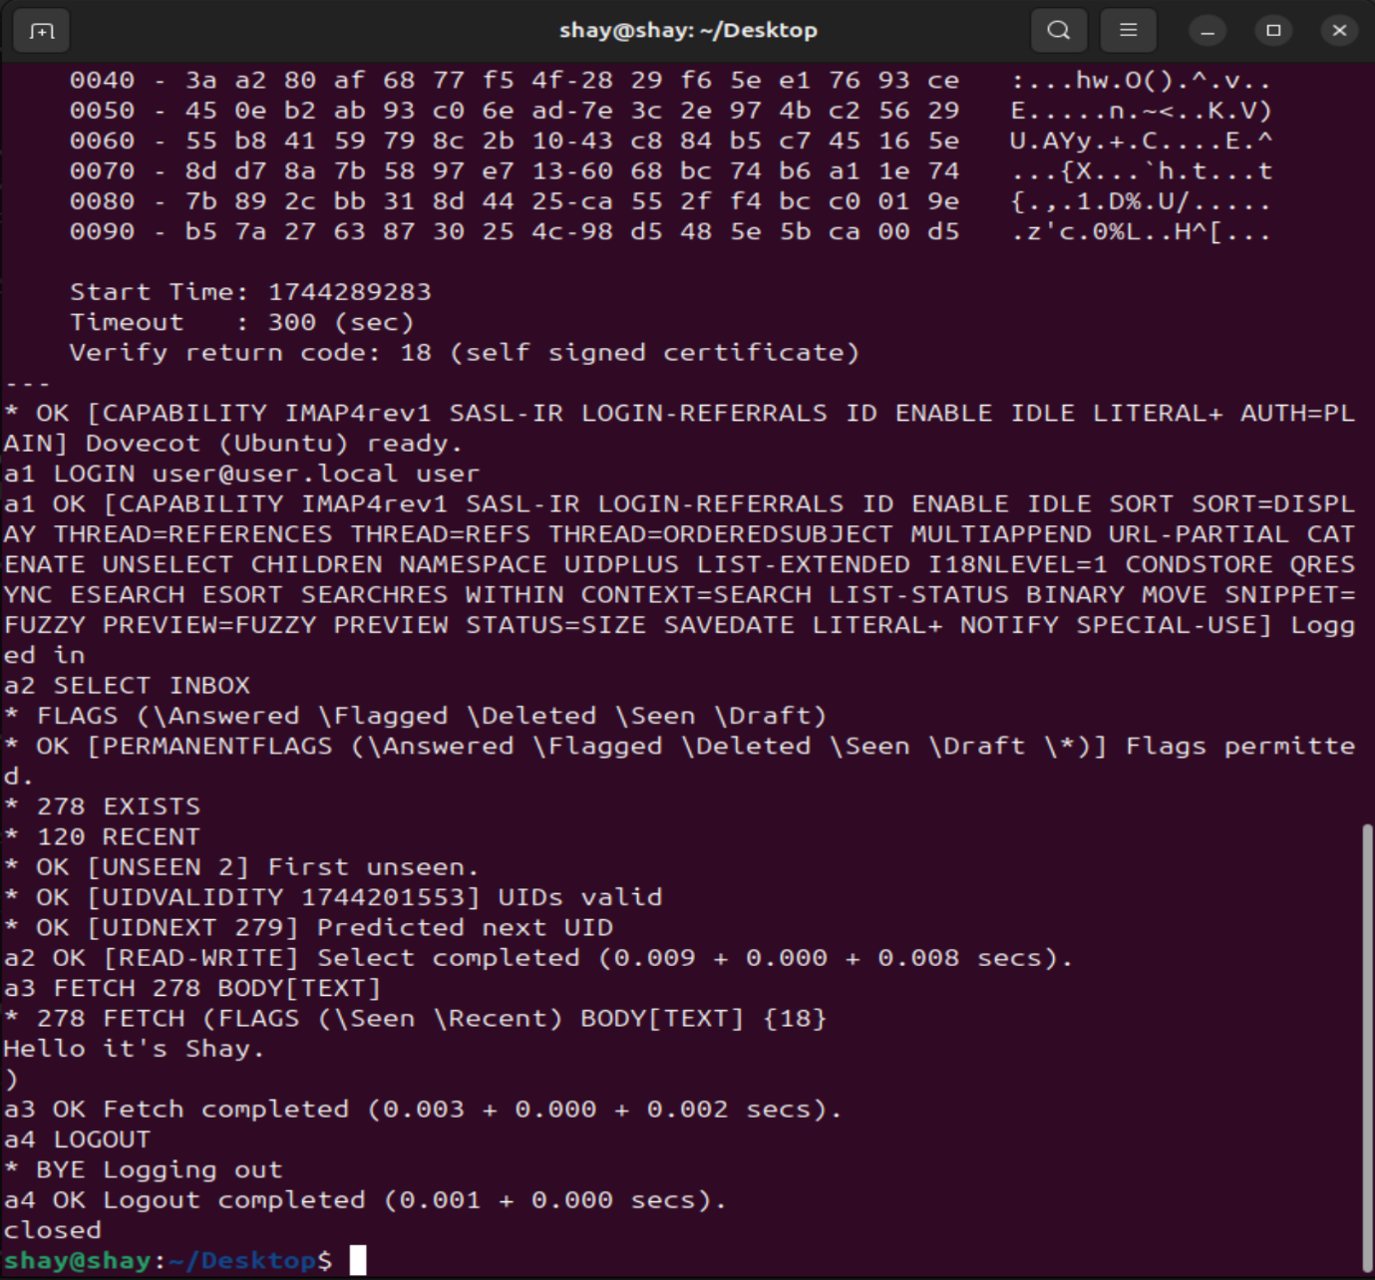**Reading email in user inbox via Dovecot with IMAP on port 993**

# **Bash Scripts for Loading Memory**

I developed two straightforward Bash scripts to populate the memory of Apache and Postfix with sensitive data for demonstration purposes.

The first script, **apache_memload.sh**, leverages a simple PHP script **(memload.php**) that generates a string containing sensitive information, such as local mail users and the mail server password. Additionally, it queries the **mailserver** database to retrieve local mail users along with their SHA-512 password hashes, embedding this data into Apache’s memory for later exploitation.

The second script, **postfix_memload.sh**, operates similarly but targets Postfix. It sends emails from shay@shay.local to user@user.local, embedding sensitive information like local mail users and the mail server password within the email payloads. This floods Postfix’s memory with exploitable data, mirroring the approach used for Apache.

* 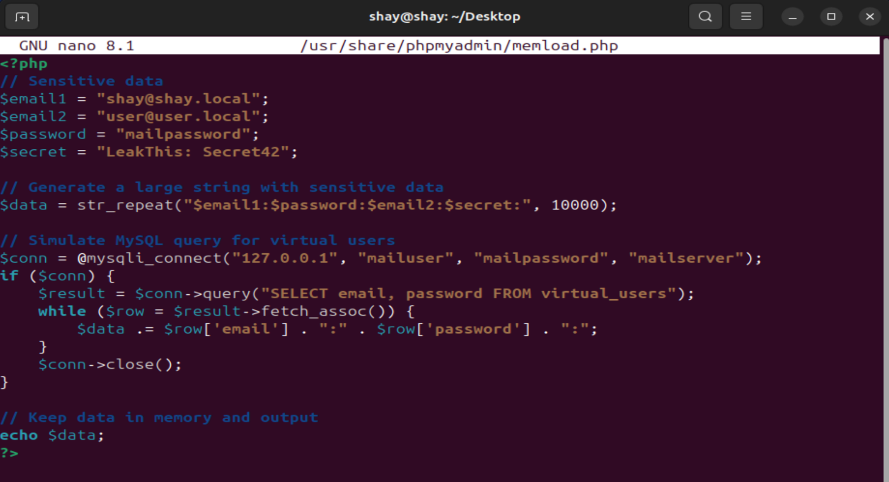**PHP script memload.php**
* **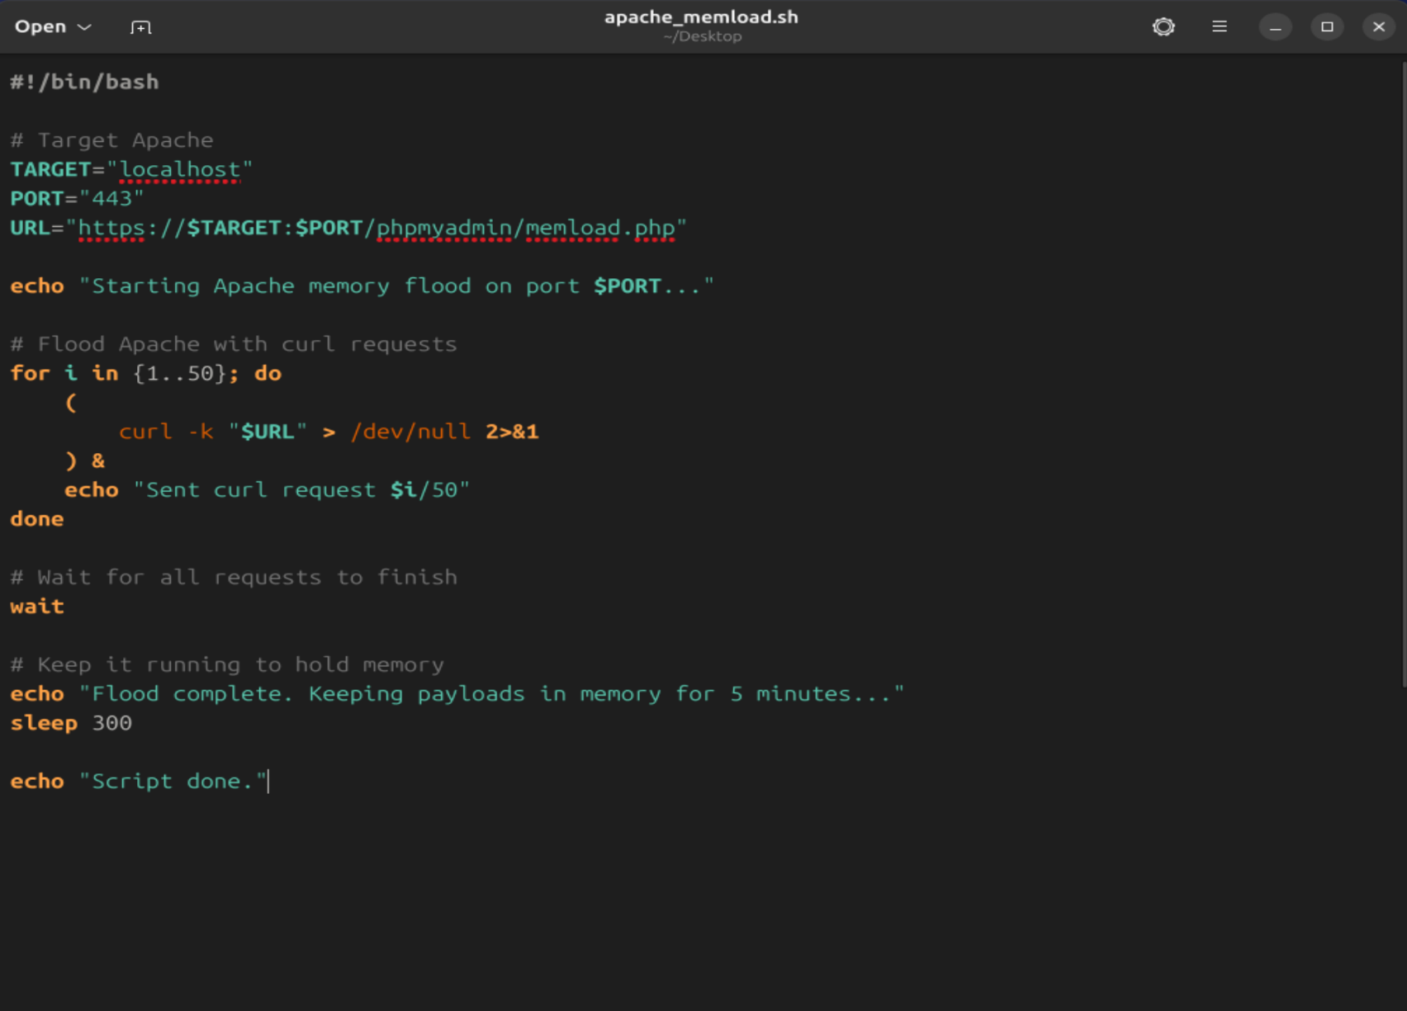****Bash script apache_memload.sh for flooding Apache**
* 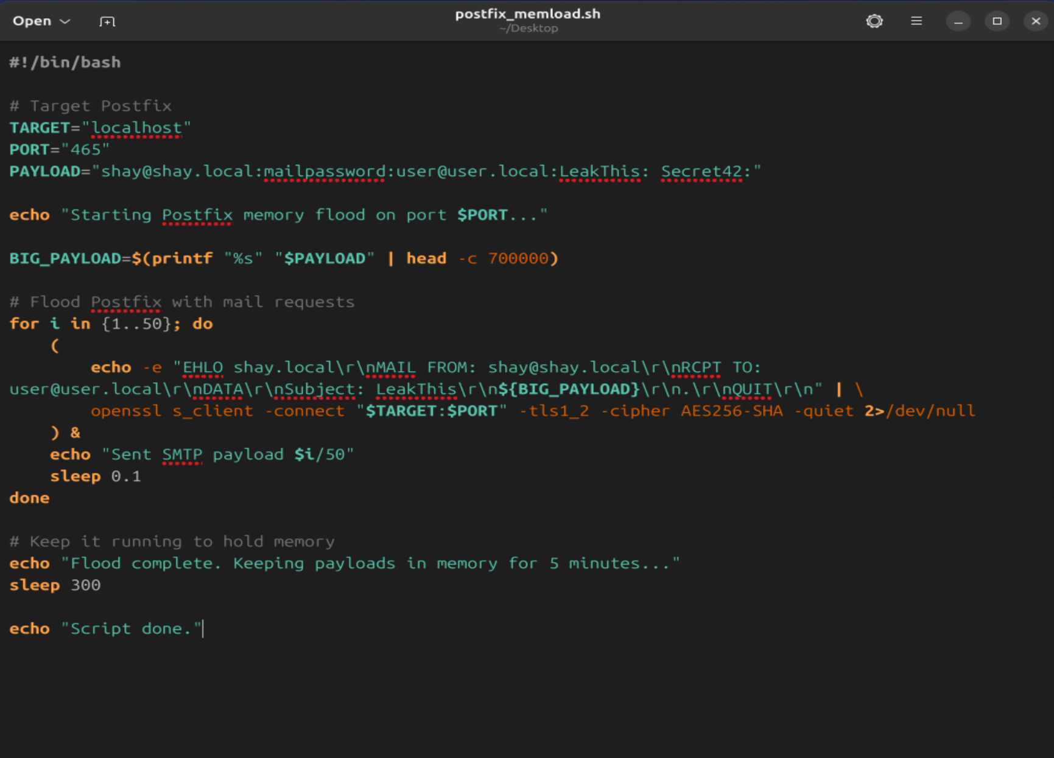**Bash script postfix_memload.sh for flooding Postfix**

# **The Java Heartbleed Exploit**

The custom Java exploit, **Heartbleed.java**, is the key tool in this demonstration, designed to exploit the Heartbleed vulnerability (CVE-2014-0160) on vulnerable server (**IP: 192.168.1.132**) running Apache and Postfix. Executed from a Windows client (**IP: 192.168.1.99**), the exploit targets unpatched OpenSSL implementations by sending malformed TLS heartbeat requests, tricking the server into leaking up to 64KB of memory per request. This memory, previously populated with sensitive data like user credentials, passwords, and certificates via scripts such as **apache_memload.sh** and **postfix_memload.sh**, is extracted and displayed for analysis, revealing the severity of the vulnerability in both services.

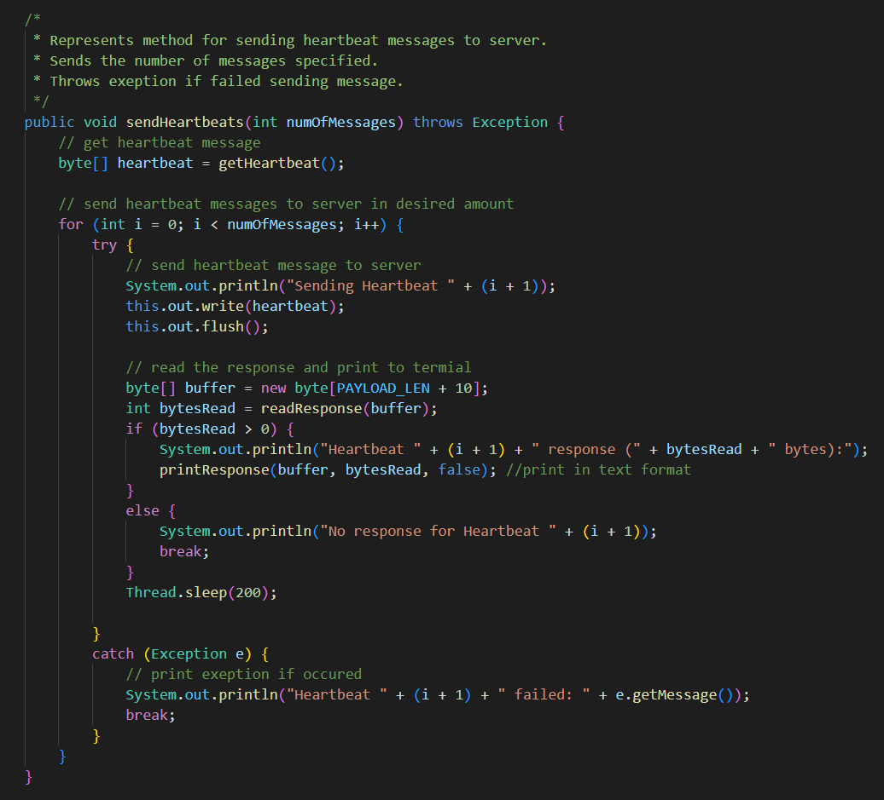The **sendHeartbeats** method, shown in the screenshot below, drives this exploitation process by managing the heartbeat requests. It repeatedly sends crafted heartbeat messages to the target server in specified amount, each designed to exploit the vulnerability by requesting more memory than intended. The method then captures and displays the server’s response, which includes the leaked data, enabling the rapid exposure of sensitive information embedded in Apache or Postfix memory, as demonstrated in the attacks on ports **443** and **465**.

# **Heartbleed Attack Demonstration**

## **Apache Attack Description**

The Apache attack commences on an Ubuntu Linux server (**IP: 192.168.1.132**), utilizing a custom Bash script**, apache_memload.sh**, to load Apache’s memory with sensitive data. As outlined previously, this script triggers a PHP file (**memload.php**) that generates a large string of sensitive information, including local mail users (e.g., shay@shay.local) and the mail server password. Additionally, the PHP script queries the mail server database to retrieve local mail users and their SHA-512 password hashes, embedding this data into Apache’s memory. These requests are served over a secure HTTPS connection on port **443**, leveraging Apache’s standard configuration.

The command to start this memory flood is: **~/Desktop/apache_memload.sh**

As the Bash script executes, it spawns 50 concurrent curl requests in parallel, embedding the sensitive data into Apache’s memory and ensuring its persistence. Simultaneously, the Windows client (**IP: 192.168.1.99**) runs my custom Java based Heartbleed exploit, targeting Apache on port **443** (HTTPS).

After confirming the Java exploit is configured for port **443** and appropriate TLS settings, the Heartbleed exploit sends malicious heartbeat requests, leveraging the Heartbleed vulnerability (CVE-2014-0160) to extract up to 64KB of memory per request from Apache. Within seconds, the exploit successfully retrieves sensitive data previously loaded by **apache_memload.sh**, including user credentials, password hashes, database fragments and SSL certificate used by Apache, highlighting Apache’s exposure to the Heartbleed vulnerability.

* 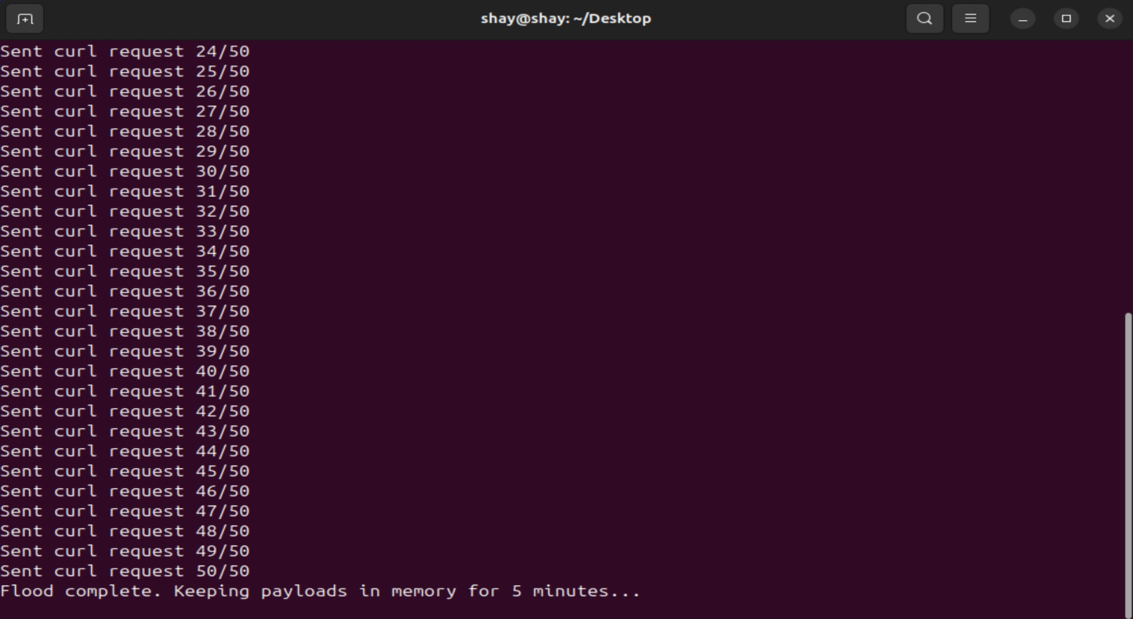**Running apache_memload.sh to load sensative data into Apache memory**
* 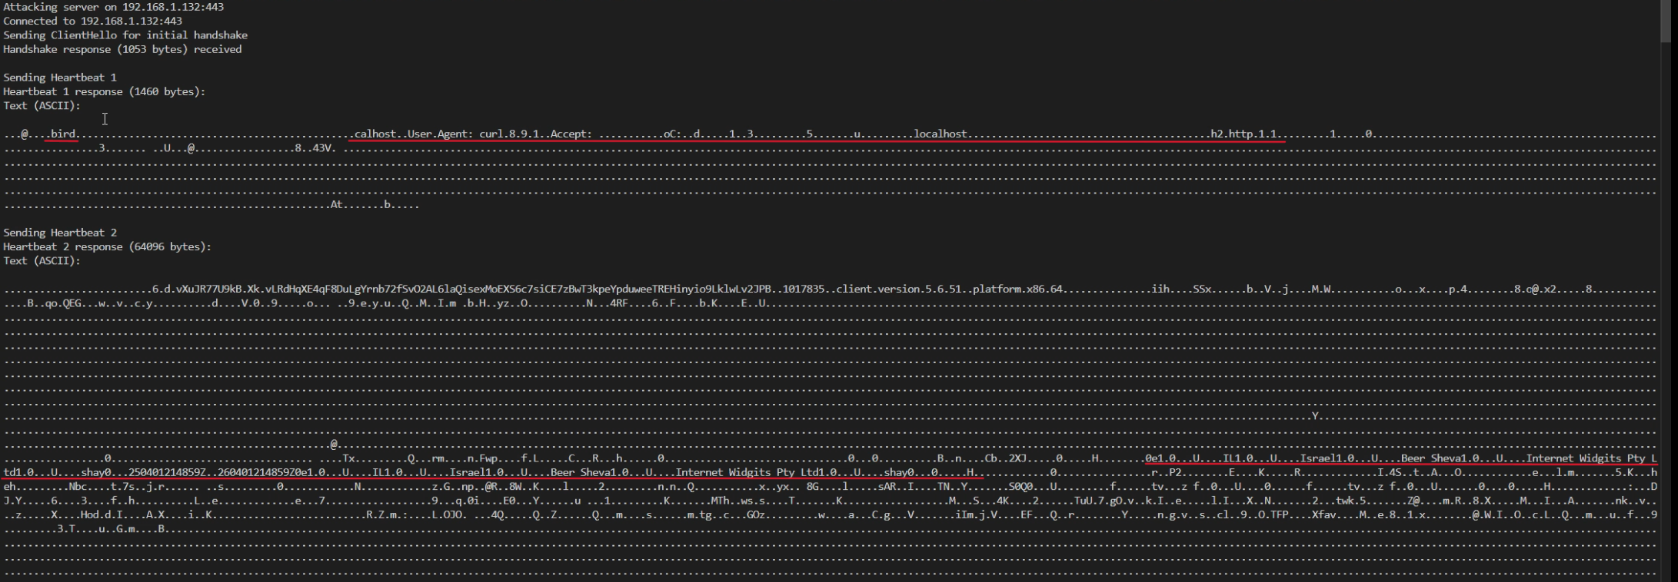**Apache leaked HTTPS request and SSL certificate that was used for TLS connection**
* 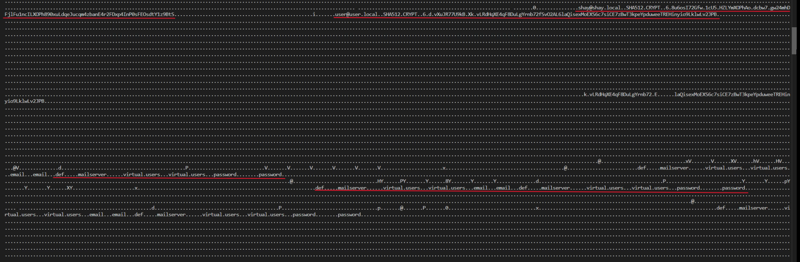**Apache leaked mail users credentials, including their SHA-512 password hashes and the mail server's database table**
* 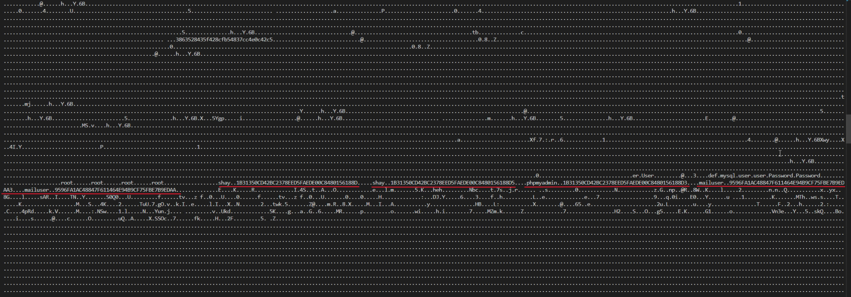**Apache leaked MySQL users credentials, including their SHA-256 password hashes**

## **Postfix Attack Description**

The Postfix attack commences on the same Ubuntu Linux server (**IP: 192.168.1.132**), utilizing another custom Bash script, **postfix_memload.sh**, to load Postfix’s memory with sensitive data. As outlined previously, this script sends 50 SMTP email payloads from shay@shay.local to user@user.local, each containing a large string of sensitive information, including local mail users (e.g., shay@shay.local) and the mail server password. These emails are transmitted over a secure TLS 1.2 connection using the AES-256 cipher, ensuring compatibility with Postfix’s configuration on port **465**.

The command to start this memory flood is: **~/Desktop/postfix_memload.sh**

As the Bash script executes, it spawns multiple SMTP sessions in parallel, embedding the sensitive data into Postfix’s memory. Simultaneously, the Windows client (**IP: 192.168.1.99**) runs my custom Java based Heartbleed exploit, this time targeting Postfix on port **465**.

After adjusting the Java exploit to use port **465** (SMTPS). The Heartbleed exploit sends malicious heartbeat requests, exploiting the Heartbleed vulnerability (CVE-2014-0160) to extract up to 64KB of memory from Postfix per request. Within a very short period, the exploit successfully retrieves the sensitive data previously loaded by **postfix_memload.sh**, such as fragments of the email header, Postfix shell commands, email credentials, mail server password and SSL certificate used by Postfix highlighting Postfix’s exposure to the Heartbleed vulnerability.

* 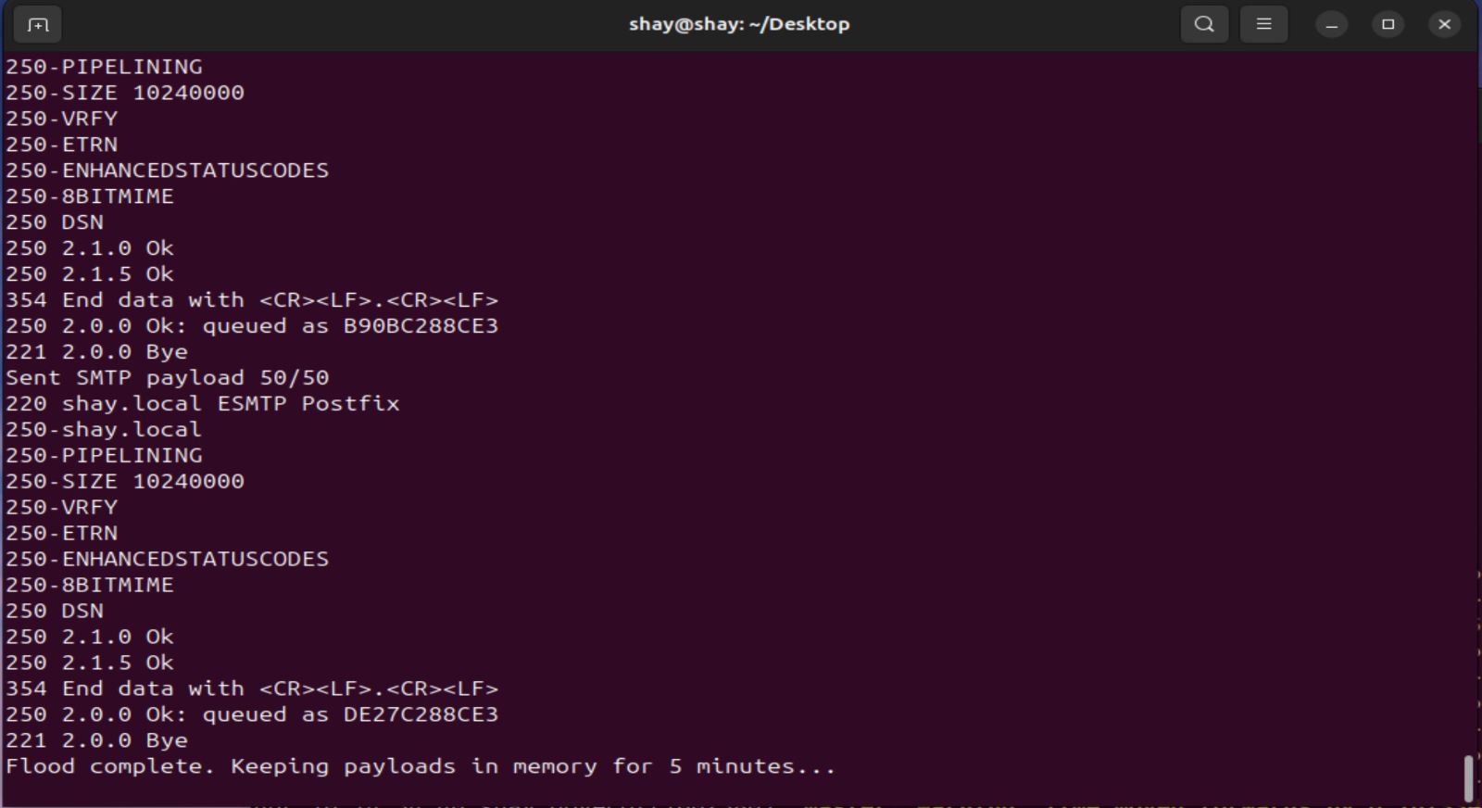**Running postfix_memload.sh to load sensative data into Postfix memory**
* 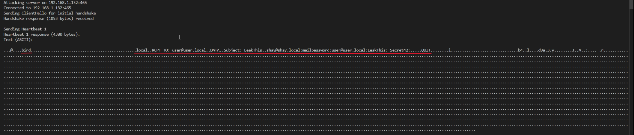**Postfix leaked shell commands used for sending email containing sensative data, including mail password**
* 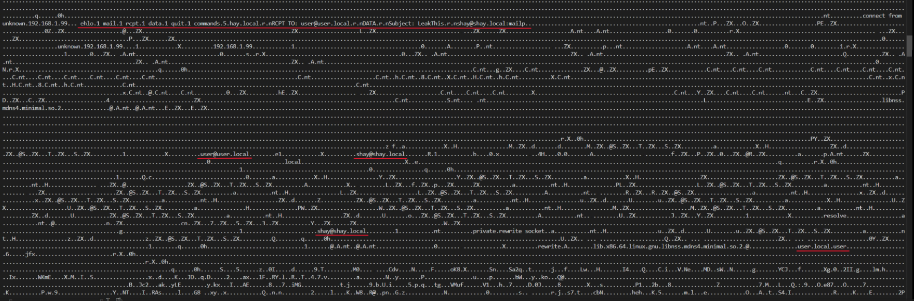**Postfix leaked the email headers of messages sent via SMTPS, including the sender and recipient information**
* 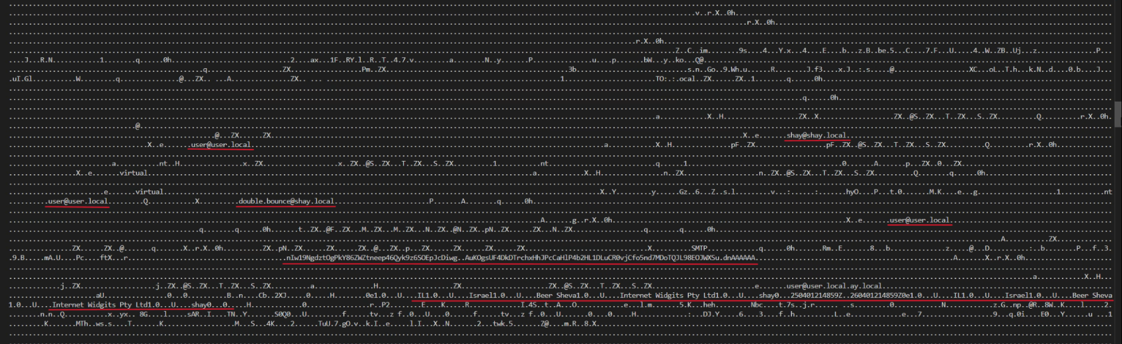**Postfix leaked mail users information and SSL certificate that was used for TLS connection**

# **Conclusion: Findings and Implications**

This demonstration successfully showcased the exploitation of the Heartbleed vulnerability (CVE-2014-0160) on an Ubuntu Linux server (**IP: 192.168.1.132**) running Apache and Postfix services. Through meticulously crafted Bash scripts such as **apache_memload.sh** and **postfix_memload.sh**, we flooded the memory of Apache (**port 443**) and Postfix (**port 465**) with sensitive data, including local mail users, mail server passwords, SHA-512 password hashes, and email credentials. My custom Java Heartbleed exploit, executed from Windows client (**IP: 192.168.1.99**), then extracted this data with alarming efficiency, retrieving up to 64KB per request from both services.

The results were striking. The Apache attack consistently leaked substantial sensitive information, such as user credentials and password hashes, within seconds, underscoring the vulnerability of web servers to Heartbleed when paired with persistent memory payloads like **memload.php**. The Postfix attack, while equally rapid, yielded a mix of email headers, shell commands, credentials, passwords, and SSL certificates, though its success varied due to Postfix’s multi-process architecture, which sometimes isolates sensitive data from the exploited memory regions. These outcomes confirm that both services, when running vulnerable OpenSSL versions (e.g., **1.0.1c**), are susceptible to unauthorized data extraction, posing significant risks to system security.

Looking ahead, these findings raise critical concerns for future mitigation. Immediate patching to OpenSSL versions beyond **1.0.1g** is essential to eliminate the Heartbleed vulnerability at its root. Beyond patching, hardening configurations, such as disabling unnecessary heartbeat extensions, enforcing stricter TLS ciphers, and minimizing memory persistence of sensitive data, can reduce exposure. Regular auditing of services like Apache and Postfix, alongside penetration testing with tools like those demonstrated here, will be vital to detect and address lingering vulnerabilities. As memory-based attacks evolve, proactive measures must keep pace to safeguard critical systems against similar exploits, ensuring the confidentiality of user data and server integrity in an increasingly hostile digital landscape.